1. **Calculating Interest rates**

**Simple Interest**

Formula: SI = P*T*R/100 , Where P is Principal, T is time, R is rate of interest

For example if

P=1000 T=10 R=8

Simple Interest = 800 for a 10 years period.

If paid Annually, the interest paid = 80

**Compound Interest**

The return on investment is higher as the interest earned is added to the principal.

Formula A = P (1 + r/n) (nt) for excel A = P(1+r/n)^nt

A = the future value of the investment including interest P = the principal investment amount (the initial deposit) r = the annual interest rate (decimal) n = the number of times that interest is compounded per year t = the number of years the money is invested

For example if P=1000 T=10 R=8

* Applying formula for annual compounding,

A = 2158

Compound Return= A-P = 1158 for 10 years at 8%

What would be the effective yield?

R=SI*100/PT

SI = 800 Compound interest = 1158

Effective yield improves from 8% to 11.58

* Applying formula for Monthly compounding

A= 2219.640235

Return = A-P 1219

SI = 800 Compound Interest, monthly compounded 1219

Effective yield improves to 12.19

* Applying formula for Daily compounding

A= 2225.34585

Return = A-P 1225.34585

SI = 800 Compound Interest=daily 1225

Effective yield improves to 12.25

Warren Buffet calls compounding as 8th wonder of the world. The effective yield improves as the number of years increase and the number of times the compounding is done in the year.

**Thumb Rule:** Number of years to double money = 72/Rate of Interest

72/8 = 9 years to double money

1. **Calculating return over appreciation in value of asset.**

Absolute Returns = (End price – beginning price)/100

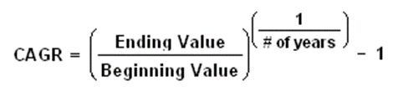

CAGR in excel =ending value/beginning value^ (1/No. of years)-1

For e.g. you bought gold for Rs.5000 per gram in 2017. If the price of gold after 5 years rises to 6000 per gram, what would be your return?

Absolute return = (6000-5000)/100 = 10%

CAGR, applying formula = 4%